Course: | Art – Fine Art
Specification and code: | Edexcel 9FA01/2
Exam Board website: | http://qualifications.pearson.com/en/qualifications/edexcel-a-levels/art-design-2008.html
Course Outline: | Year one: building practical skills, material experiments and explorations, research, informed responses, practical and written analysis, planning, decision making and personal outcomes. Much of your work will be done in sketchbooks; these must be continually annotated, to explain and express your personal understanding and interpretation of the work. A Life drawing class will run for 6 weeks after school.  All students work on coursework across both years and the course will conclude with a single exam at the end of Year 13.  Year two: building upon the knowledge, understanding and skills gained, you are expected to develop a chosen area into work of greater depth and sophistication. You will be given continued help and guidance, not least in deciding on an appropriate area of study. However, it is expected that students will show a more highly developed sense of responsibility for their work and will take on personal challenges and push themselves to create a thoughtful and substantial portfolio of coursework. Alongside practical work, you will produce an extended personal written investigation. This will be in the form of an illustrated essay (minimum 1000 words).  Exam: From a given starting point students will develop work in much the same way as for coursework, in the form of research, exploration, investigation, experiment, and personal responses. The assignment will conclude with a fifteen hour period of supervised work, which will be in the form of an outcome linked to these investigations.
Summer Task: | Your task over the summer is to start a sketchbook which relates to the theme of Portraiture and The Figure. We would like you to develop a series of pages which relate to this topic and focus on developing your own practical work. You could use a range of materials and techniques and look at artists for inspiration. Ideally you could finish the little sketchbook that you started during the Yr 11 A Level Induction lesson in June.  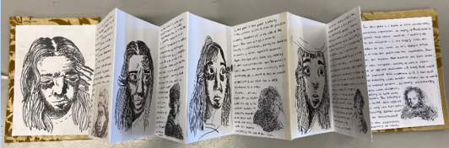  You could generate a series of drawings from direct observation. You could work from photographs and images that you have found and collected.  Artists that you could look at for inspiration: Lucien Freud; Rembrandt ; Egon Schiele; Picasso; Otto Dix; Van Gogh; Leonardo Da Vinci; Rodin; Chuck Close  Google drawings by these artists, and try working in a similar style.  Explore drawing styles - Tone / Linear / Continuous Line / Sketching  You may decide to zoom in and draw parts of a face or the figure.  You may decide to take interesting photographs to work from.
Extension | Over the summer you could visit art galleries and document your visit. You could take photographs and present them in your sketchbook. You could write about your visit and your experience.

