06 October 2025

Dear Parents and Carers

I am writing to let you know that at some point during this half term there will be a visit by a specially trained community safety dog and its handler on the school premises.

Secondary Schools in Dorset, including Colfox, have been taking part in this countywide initiative for several years. It follows on from a successful visit last year, and is part of the ongoing education programme about substance abuse. It is important to safeguard our students and make it very clear that drugs will not be tolerated.

We appreciate your support.

Yours sincerely
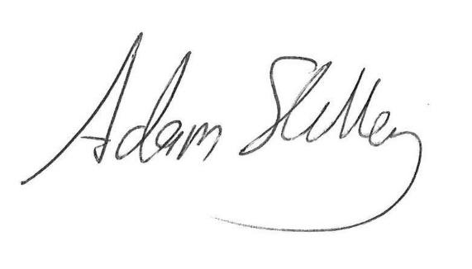
Adam Shelley
Headteacher

