BTEC Revision
Booklet
Skeletal System



A The effects of exercise and sports performance on the skeletal system

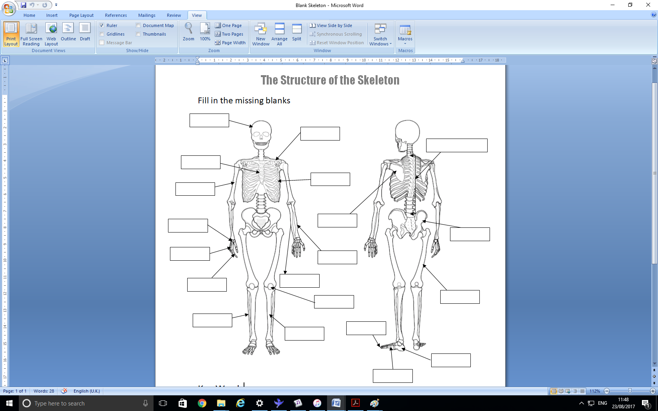
A1 Structure of skeletal system

Ulna | Tarsals | Radius | Phalanges
Pelvis | Cranium | Carpals | Metatarsals
Femur | Humerus | Scapula | Phalanges
Tibia | Ribs | Vertebral Column | Clavicle
Fibula | Patella | Sternum | Metacarpals

Types of bones
Type of bone | Characteristics | Examples
1.

2.

3.

4.

5.

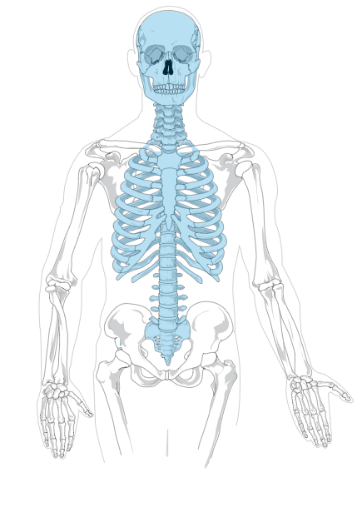
Areas of the skeleton
Area of the skeleton | Bones
1.

2.

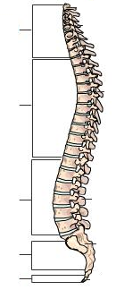
Verterbral column
Main Functions

_______________________________________________________________________________________________________________________________________________________________________________________________________________________________________________________________________________________

Section | Function
1.

2.

3.

4.

5.

Postural defects
Defect | Picture | Description
Neutral Spine | 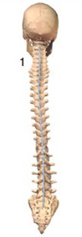  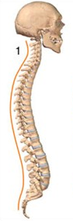
 | 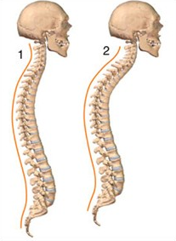
 | 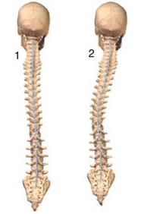

Process of bone growth
Ossification:_____________________________________________________________________________________________________________________________
Epiphyseal plates:____________________________________________________
____________________________________________________________________
Epiphyseal line:______________________________________________________
____________________________________________________________________
Osteoblasts:_____________________________________________________________________________________________________________________________
Osteoclasts:_____________________________________________________________________________________________________________________________

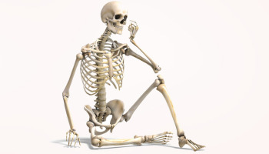

A2 Functions of skeletal system

Function | Explanation/Example
1.

2.

3.

4.

5.

6.

7.

8.

Function of bones
Type of bone | Examples | Function
1.

2.

3.

4.

5.

A3 Joints
Classification of joints
Type of Joint | Characteristics | Examples
1.

2.

3.

Structure of synovial joints
Key words
Synovial fluid:
________________________________________________
Synovial membrane:
________________________________________________
Articular cartilage:
________________________________________________
Joint capsule:
________________________________________________
Ligament:
________________________________________________
Bursa:
________________________________________________

Label a synovial joint
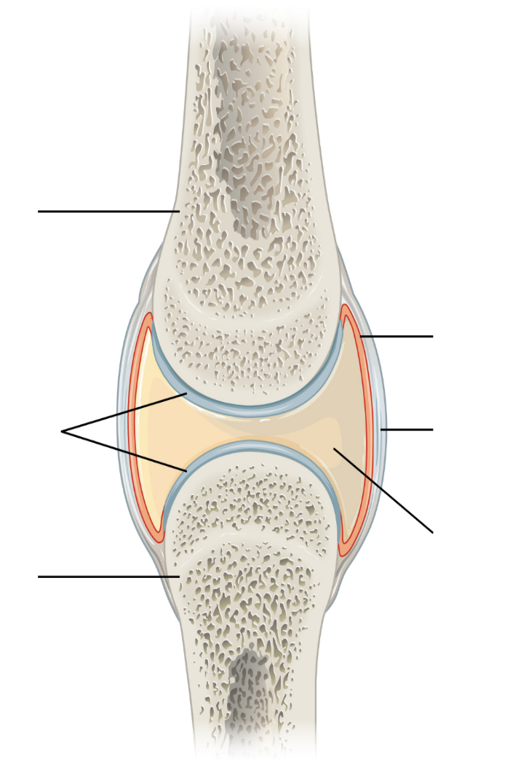

Picture | Type of Joint | Example | Bones that form the joint
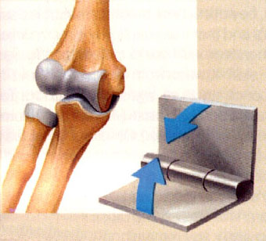
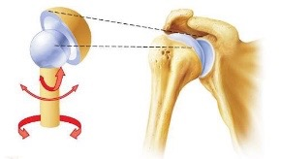
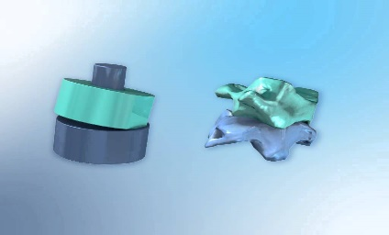
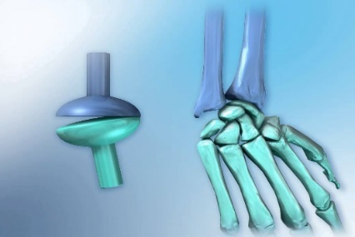
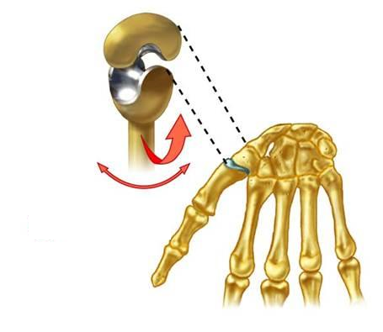
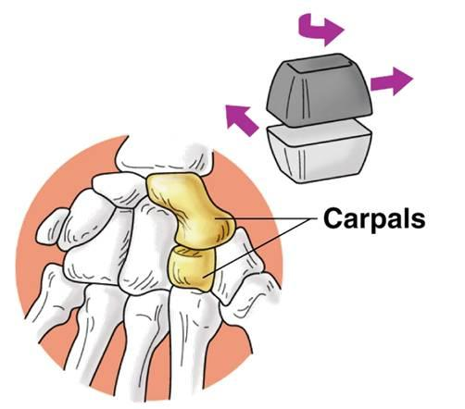

Types of synovial joints
Types of movement at synovial joints
Movement | Definition | Example
1.

2.

3.

4.

5.

6.

7.

8.

9.

10.

11.

12.

13.

14.

A4 Responses of the skeletal system to a single sport or exercise session
- ______________________________________________________________________________________________________________________________
- ______________________________________________________________________________________________________________________________
- ______________________________________________________________________________________________________________________________

A5 Adaptations of the skeletal system to exercise
- ____________________________________________________________________________________________________________________________________________________________________________________________________________________________________________________________
- ____________________________________________________________________________________________________________________________________________________________________________________________________________________________________________________________

A5 Additional factors affecting the skeletal system

Arthritis
Osteoporosis
Age

Apply your Knowledge!
The skeleton has a number of important functions, explain the importance of these when participating in a boxing match?
________________________________________________________________________________________________________________________________________________________________________________________________________________________________________________________________________________________________________________________________________________________________________________________________________________________________________________________________________________________________________________________________________________________________________________________________________________________________________________________________________________________________________________________________________________________________________________________________________________________________________________________________________________________________________________________________________________________________________________________________________________________________________________________________________________________________________________________________________________________________
6 Marks
Explain the process of bone growth?
____________________________________________________________________________________________________________________________________________________________________________________________________________________________________________________________________________________________________________________________________________________________________________________________________________________________________________________________________________________________________________________________________________________________________________________________________________________________________________________________________________________________________________________________
4 Marks
Draw a synovial joint below and explain the importance of the various structures in a game of football?

________________________________________________________________________________________________________________________________________________________________________________________________________________________________________________________________________________________________________________________________________________________________________________________________________________________________________________________________________________________________________________________________________________________________________________________________________________________________________________________________________________________________________________________________________________________________________________________________________________________________________________________________________________________________________________________________________________________________________________________________________________________________________________________________________________________________________________________________________________________________
10 Marks
Bones hve many different functions depending on their shape and location. Explain how the different types of bones are used during a game of netball?
__________________________________________________________________________________________________________________________________________________________________________________________________________________________________________________________________________________________________________________________________________________________________________________________________________________________________________________________________________________________________________________________________________________________________________________________________________________________________________________________________________________________________________________________________________________________________________________________________________________________________________________________________________________________________________________________________________________________________________________________________________________________________________________________________________________________
8 Marks
Label each of the five regions of the vertebrea and give a brief description of thieir function?
____________________________________________________________________________________________________________________________________________________________________________________________________________________________________________________________________________________________________________________________________________________________________________________________________________________________________________________________________________________________________________
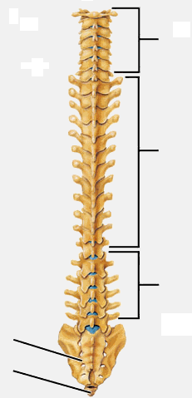

6 Marks
Below is a picture of a gymnast. Name the type of synovial joints that are highlighted and the bones that make up the joint?
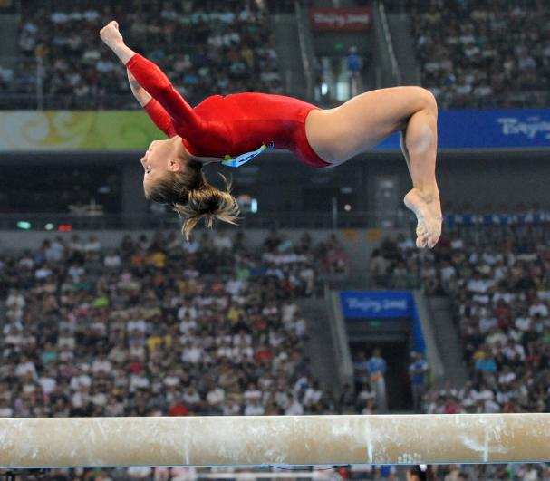
__________________________________________________________________________________________________________________

__________________________________________________________________________________________________________________
6 Marks
Below is a picture of a swimmer performing a butterfly stroke explain the types of movement happening at the shoulder joint?
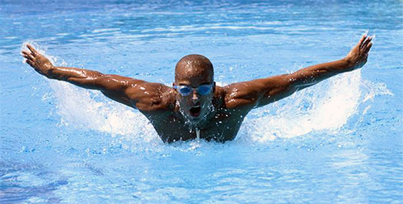
________________________________________________________________________________________________________________________________________________________________________________________________________________________
4 Marks
Cricketers us a large number of synovial joints when bowling, explain how the various synovial joints in the body help aid movement when bowling?
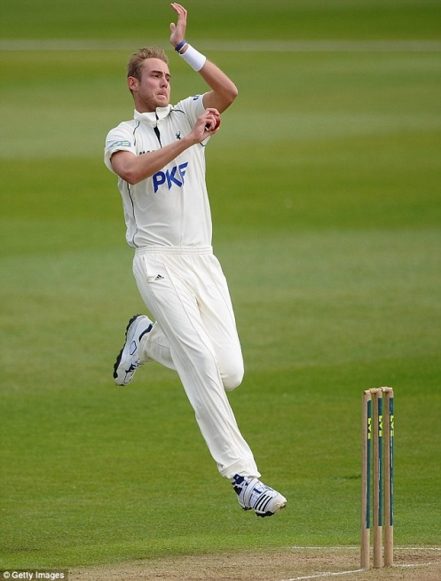
______________________________________________________________________________________________________________________________________________________________________________________________________________________________________________________________________________________________________________________________________________________________________________________________________________________________________________________________________________________________________________________________
6 Marks
In the picture below name the highlighted synovial joint and the type of movement created?
Type of joint: __________________________
Movement created: __________________________
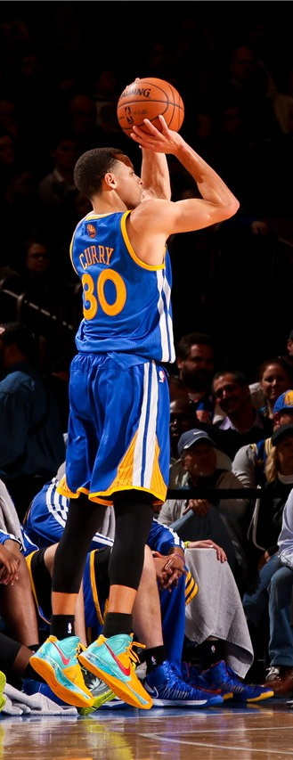
Type of joint: __________________________
Movement created: __________________________
Type of joint: __________________________
Movement created: __________________________
Type of joint: __________________________
Movement created: __________________________

Resistance training can have many benefits to the skeletal system. However it may cause more harm than good to children, Explain?
____________________________________________________________________________________________________________________________________________________________________________________________________________________________________________________________________________________________________________________________________________________________________________________________________________________________________________________________________________________________________________________________________________________________________________________________________________________________________________________________________________________________________________________________
4 Marks
The benefits of taking part in regular exercise are huge. Exercise should be a part of a health active lifetyle. Explain how exercise can benefit skeletal diseases such as arthritis and osteporosis?
__________________________________________________________________________________________________________________________________________________________________________________________________________________________________________________________________________________________________________________________________________________________________________________________________________________________________________________________________________________________________________________________________________________________________________________________________________________________________________________________________________________________________________________________________________________________________________________________________
6 Marks
When we take part in regular exercise it benefits our performance. Explain how the adaptions of the skeletal system to exercise will improve your performance in a game ofrugby?
____________________________________________________________________________________________________________________________________________________________________________________________________________________________________________________________________________________________________________________________________________________________________________________________________________________________________________________________________________________________________________________________________________________________________________________________________________________________________________________________________________________________________________________________________________________________________________________________________________________________________________________________________________________________________________________________________________________________________________________________________________________
8 Marks
Fill in the table below?
Range of movement | Description
 | The movement of bending sideways.
 | Reducing the angle between bones at a joint. E.g. bending.
 | Movement towards the body’s vertical midline.
 | Movement of pulling the toes towards the knee.
 | A circular motion.
 | Movement of bringing your arm across your body.
 | A movement beyond the normal anatomical position in a direction opposite to flexion.
 | A circular motion that results in a conical motion.
 | Straightening of a limb to increase the angle at a joint.
 | Movement of pointing the toes downwards.
 | Bending the elbow while the arm is held out.
 | A movement away from the body’s midline.
 | Movement of bringing your arm backwards from across your body.
 | Straightening the elbow while the arm is held out.
7 Marks
Name and describe the postural deviation in the picture below?
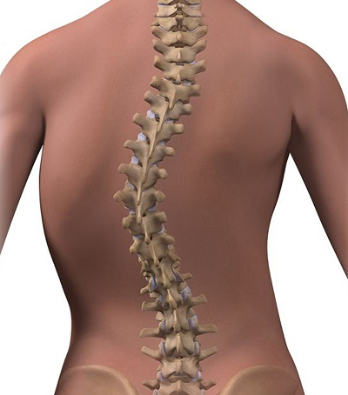
________________________________________________________________________________________________________________________________________________________________________________________________________________________________________________________________________________________________________________________________________________________________________________________________
4 Marks
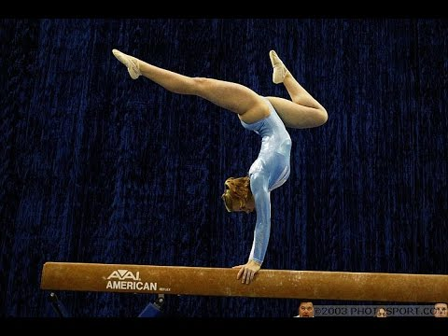
Explain and how the function of the skeleton helps the gymnast get into and hold the postion below?
__________________________________________________________________________________________________________________________________________________________________________________________________________________________________________________________________________________________________________________________________________________________________________________________________________________________________________________________________________________________________________________________________________________________________________________________________________________________________________________________________________________________________________________________________________________________________________________________________________________________________________________________________________________________________________________________________________________________________________________________________________________________________________________________________________________________________________________________________________________________________________________________________________________________________________________________________________________________________________________________________________________________________________________
8 Marks

